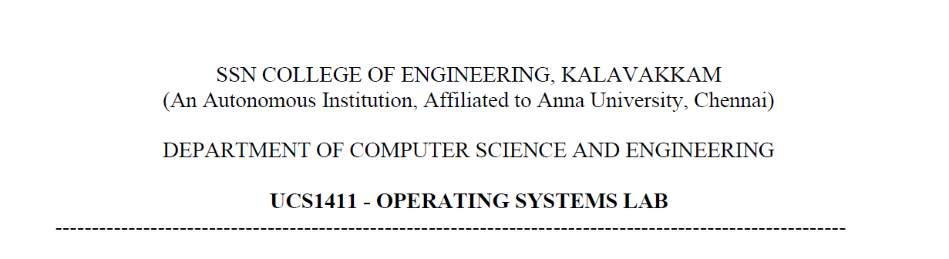

**UCS1412 – DBMS Lab**

**Assignment – 3**

Name: Jayannthan P T

Dept: CSE ‘A’

Roll No.: 205001049

**Title:** Bakery Database

**Schema Diagram:**

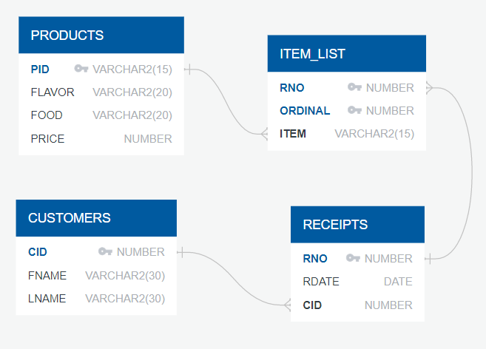

**Spool File Output for Table Creation:**

SQL> @D:/assn3create;

SQL> *--  DROPPING ALL TABLES*

SQL> DROP TABLE ITEM_LIST;

Table ITEM_LIST dropped.

SQL> DROP TABLE RECEIPTS;

Table RECEIPTS dropped.

SQL> DROP TABLE PRODUCTS;

Table PRODUCTS dropped.

SQL> DROP TABLE CUSTOMERS;

Table CUSTOMERS dropped.

SQL>

SQL> *--  CREATING CUSTOMERS TABLE*

SQL> CREATE TABLE CUSTOMERS

  2  (

  3      CID **NUMBER** **CONSTRAINT** CUSID_PKEY PRIMARY KEY,

  4      FNAME **VARCHAR2**(30),

  5      LNAME **VARCHAR2**(30)

  6  );

Table CUSTOMERS created.

SQL>

SQL> *--  DISPLAYING THE ATTRIBUTES AND THEIR DATA TYPES OF THE CUSTOMERS TABLE*

SQL> DESC CUSTOMERS;

Name  Null?    Type

*----- -------- ------------*

CID   NOT NULL **NUMBER**

FNAME          **VARCHAR2**(30)

LNAME          **VARCHAR2**(30)

SQL>

SQL> *--  CREATING PRODUCTS TABLE*

SQL> CREATE TABLE PRODUCTS

  2  (

  3      PID **VARCHAR2**(15) **CONSTRAINT** PRODUCTS_PKEY PRIMARY KEY,

  4      FLAVOR **VARCHAR2**(20),

  5      FOOD **VARCHAR2**(20),

  6      PRICE **NUMBER**

  7  );

Table PRODUCTS created.

SQL>

SQL> *--  DISPLAYING THE ATTRIBUTES AND THEIR DATA TYPES OF THE PRODUCTS TABLE*

SQL> DESC PRODUCTS;

Name   Null?    Type

*------ -------- ------------*

PID    NOT NULL **VARCHAR2**(15)

FLAVOR          **VARCHAR2**(20)

FOOD            **VARCHAR2**(20)

PRICE           **NUMBER**

SQL>

SQL> *--  CREATING RECEIPTS TABLE*

SQL> CREATE TABLE RECEIPTS

  2  (

  3      RNO **NUMBER** **CONSTRAINT** RNO_PKEY PRIMARY KEY,

  4      RDATE DATE,

  5      CID **NUMBER** **CONSTRAINT** CUSID_FORKEY **REFERENCES** CUSTOMERS(CID)

  6  );

Table RECEIPTS created.

SQL>

SQL> *--  DISPLAYING THE ATTRIBUTES AND THEIR DATA TYPES OF THE RECEIPTS TABLE*

SQL> DESC RECEIPTS;

Name  Null?    Type

*----- -------- ------*

RNO   NOT NULL **NUMBER**

RDATE          DATE

CID            **NUMBER**

SQL>

SQL> *--  CREATING TABLE ITEM_LIST*

SQL> CREATE TABLE ITEM_LIST

  2  (

  3      RNO **NUMBER** **CONSTRAINT** RECEIPTNO_FORKEY **REFERENCES** RECEIPTS(RNO),

  4      ORDINAL **NUMBER** **CONSTRAINT** ITEM_CHK **CHECK**(ORDINAL!=0),

  5      ITEM **VARCHAR2**(15) **CONSTRAINT** PID_FORKEY **REFERENCES** PRODUCTS(PID),

  6      **CONSTRAINT** ITEM_LIST_FORKEY PRIMARY KEY(RNO,ORDINAL)

  7  );

Table ITEM_LIST created.

SQL>

SQL> *--  DISPLAYING THE ATTRIBUTES AND THEIR DATA TYPES OF THE ITEM_LIST TABLE*

SQL> DESC ITEM_LIST;

Name    Null?    Type

*------- -------- ------------*

RNO     NOT NULL **NUMBER**

ORDINAL NOT NULL **NUMBER**

ITEM             **VARCHAR2**(15)

SQL> spool off;

**Spool File Output for insertion into Customers table:**

SQL> *-- REM Population of Bakery Database*

SQL> *-- REM --------------------------------------------------------------------------*

SQL> *-- REM CUSTOMERS ( customer number,  Last name, First name)*

SQL> *-- REM --------------------------------------------------------------------------*

SQL>

SQL> insert into customers values(1, 'LOGAN', 'JULIET');

1 row inserted.

SQL> insert into customers values(2, 'ARZT', 'TERRELL');

1 row inserted.

SQL> insert into customers values(3, 'ESPOSITA', 'TRAVIS');

1 row inserted.

SQL> insert into customers values(4, 'ENGLEY', 'SIXTA');

1 row inserted.

SQL> insert into customers values(5, 'DUNLOW', 'OSVALDO');

1 row inserted.

**Spool File Output for insertion into Products table:**

SQL>

SQL> *-- REM --------------------------------------------------------------------------*

SQL> *-- REM PRODUCTS (product number,  Flavor, Food, Price)*

SQL> *-- REM --------------------------------------------------------------------------*

SQL>

SQL> insert into products values('20-BC-C-10','Chocolate','Cake',8.95);

1 row inserted.

SQL> insert into products values('20-BC-L-10','Lemon','Cake',8.95);

1 row inserted.

SQL> insert into products values('20-CA-7.5','Casino','Cake',15.95);

1 row inserted.

SQL> insert into products values('24-8x10','Opera','Cake',15.95);

1 row inserted.

SQL> insert into products values('25-STR-9','Strawberry','Cake',11.95);

1 row inserted.

**Spool File Output for insertion into Receipts table:**

SQL>

SQL> *-- REM --------------------------------------------------------------------------*

SQL> *-- REM RECEIPTS(receipt number, receipt Date, Customer)*

SQL> *-- REM --------------------------------------------------------------------------*

SQL>

SQL> INSERT INTO Receipts values(18129, '28-Oct-2007', 15);

1 row inserted.

SQL> INSERT INTO Receipts values(51991, '17-Oct-2007', 14);

1 row inserted.

SQL> INSERT INTO Receipts values(83085, '12-Oct-2007', 7);

1 row inserted.

SQL> INSERT INTO Receipts values(70723, '28-Oct-2007', 20);

1 row inserted.

SQL> INSERT INTO Receipts values(13355, '19-Oct-2007', 7);

1 row inserted.

**Spool File Output for insertion into ITEM_LIST table:**

SQL>

SQL> *-- REM --------------------------------------------------------------------------*

SQL> *-- REM* *ITEM_LIST (receipt number,  Ordinal, Item)*

SQL> *-- REM --------------------------------------------------------------------------*

SQL>

SQL> insert into item_list values(18129, 1,  '70-TU');

1 row inserted.

SQL> insert into item_list values(51991, 1,  '90-APIE-10');

1 row inserted.

SQL> insert into item_list values(51991, 2,  '90-CH-PF');

1 row inserted.

SQL> insert into item_list values(51991, 3,  '90-APP-11');

1 row inserted.

**Spool File Output for given Questions:**

SQL>

SQL> @"D:\assn3Qns.sql"

SQL> *-- ASSIGNMENT 3*

SQL>

SQL> *-- WRITE THE FOLLOWING USING SUB-QUERY:*

SQL> *-- 1. DISPLAY THE FOOD DETAILS THAT IS NOT PURCHASED BY ANY OF CUSTOMERS.*

SQL>

SQL> SELECT * FROM PRODUCTS

  2  WHERE PID NOT IN(SELECT ITEM FROM ITEM_LIST);

PID             FLAVOR               FOOD                      PRICE

*--------------- -------------------- -------------------- ----------*

20-BC-C-10      Chocolate            Cake                       8.95

SQL>

SQL> *-- 2. SHOW THE CUSTOMER DETAILS WHO HAD PLACED MORE THAN 2 ORDERS ON THE SAME DATE.*

SQL>

SQL> SELECT * FROM CUSTOMERS

  2  WHERE CID IN(SELECT CID FROM RECEIPTS

  3  GROUP BY CID,RDATE

  4  HAVING COUNT(*)>2);

       CID FNAME                          LNAME

*---------- ------------------------------ ------------------------------*

        14 SOPKO                          RAYFORD

         8 HELING                         RUPERT

SQL>

SQL> *-- 3. DISPLAY THE PRODUCTS DETAILS THAT HAS BEEN ORDERED MAXIMUM BY THE CUSTOMERS. (USE*

SQL> *-- ALL)*

SQL>

SQL> SELECT * FROM PRODUCTS

  2  WHERE PID IN (SELECT ITEM FROM ITEM_LIST GROUP BY ITEM

  3  HAVING COUNT(*) >= ALL (SELECT COUNT(*) FROM ITEM_LIST GROUP BY ITEM));

PID             FLAVOR               FOOD                      PRICE

*--------------- -------------------- -------------------- ----------*

90-APP-11       Apple                Tart                       3.25

SQL>

SQL>

SQL> *-- 4. SHOW THE NUMBER OF RECEIPTS THAT CONTAIN THE PRODUCT WHOSE PRICE IS MORE THAN THE*

SQL> *-- AVERAGE PRICE OF ITS FOOD TYPE.*

SQL>

SQL> SELECT COUNT(DISTINCT RNO) AS RECEIPT_COUNT FROM ITEM_LIST

  2  WHERE ITEM IN (SELECT PID  FROM PRODUCTS OUTER

  3  WHERE PRICE > (SELECT AVG(PRICE) FROM PRODUCTS WHERE FOOD=OUTER.FOOD));

RECEIPT_COUNT

*-------------*

          137

SQL>

SQL>

SQL> *-- WRITE THE FOLLOWING USING JOIN: (USE SUB-QUERY IF REQUIRED)*

SQL> *-- 5. DISPLAY THE CUSTOMER DETAILS ALONG WITH RECEIPT NUMBER AND DATE FOR THE RECEIPTS THAT*

SQL> *-- ARE DATED ON THE LAST DAY OF THE RECEIPT MONTH.*

SQL>

SQL> SELECT DISTINCT CID,FNAME,LNAME,RNO,RDATE

  2  FROM CUSTOMERS C NATURAL JOIN RECEIPTS R

  3  WHERE R.RDATE=LAST_DAY(R.RDATE);

       CID FNAME                          LNAME                                 RNO RDATE

*---------- ------------------------------ ------------------------------ ---------- --------*

        11 STADICK                        MIGDALIA                            60270 31-10-07

        20 ZEME                           STEPHEN                             49845 31-10-07

         3 ESPOSITA                       TRAVIS                              39829 31-10-07

        19 STENZ                          NATACHA                             36343 31-10-07

        12 MCMAHAN                        MELLIE                              70796 31-10-07

         1 LOGAN                          JULIET                              85858 31-10-07

6 rows selected.

SQL>

SQL> *-- 6. DISPLAY THE RECEIPT NUMBER(S) AND ITS TOTAL PRICE FOR THE RECEIPT(S) THAT CONTAIN TWIST*

SQL> *-- AS ONE AMONG FIVE ITEMS. INCLUDE ONLY THE RECEIPTS WITH TOTAL PRICE MORE THAN $25.*

SQL>

SQL> SELECT RNO, SUM(PRICE) AS TOTALPRICE FROM ITEM_LIST I JOIN PRODUCTS P ON (I.ITEM = P.PID)

  2  WHERE RNO IN (SELECT RNO FROM ITEM_LIST I JOIN PRODUCTS P ON (I.ITEM = P.PID) WHERE FOOD='Twist')

  3  GROUP BY RNO HAVING FLOOR(SUM(PRICE)) >25;

       RNO TOTALPRICE

*---------- -----------*

*17729 25.55*

*64477 25.35*

*83085 48.25*

SQL>

SQL> *-- 7. DISPLAY THE DETAILS (CUSTOMER DETAILS, RECEIPT NUMBER, ITEM) FOR THE PRODUCT THAT WAS PURCHASED BY THE LEAST NUMBER OF CUSTOMERS.*

SQL>

SQL> SELECT DISTINCT CUSTOMERS.CID,FNAME,LNAME,RECEIPTS.RNO,ITEM

  2  FROM CUSTOMERS,RECEIPTS,ITEM_LIST

  3  WHERE CUSTOMERS.CID=RECEIPTS.CID AND RECEIPTS.RNO=ITEM_LIST.RNO AND ITEM IN

  4  (SELECT ITEM FROM ITEM_LIST GROUP BY ITEM HAVING COUNT(*)=(SELECT MIN(COUNT(*)) FROM ITEM_LIST GROUP BY ITEM));

       CID FNAME                          LNAME                                 RNO ITEM

*---------- ------------------------------ ------------------------------ ---------- ---------------*

        20 ZEME                           STEPHEN                             49845 50-CH

        18 DOMKOWSKI                      ALMETA                              82056 50-CH

        18 DOMKOWSKI                      ALMETA                              73716 50-CH

         6 SLINGLAND                      JOSETTE                             99994 50-CH

        14 SOPKO                          RAYFORD                             77032 50-CH

         8 HELING                         RUPERT                              95962 50-CH

6 rows selected.

SQL>

SQL> *-- 8. DISPLAY THE CUSTOMER DETAILS ALONG WITH THE RECEIPT NUMBER WHO ORDERED ALL THE FLAVORS OF MERINGUE IN THE SAME RECEIPT.*

SQL>

SQL> SELECT DISTINCT CID, FNAME,LNAME,RNO FROM CUSTOMERS NATURAL JOIN RECEIPTS

  2  WHERE RNO IN (SELECT RNO FROM (SELECT DISTINCT RNO, FLAVOR FROM PRODUCTS JOIN ITEM_LIST ON(ITEM=PID)

  3  WHERE FOOD='Meringue' GROUP BY RNO,FLAVOR) GROUP BY RNO HAVING COUNT(*)>1);

       CID FNAME                          LNAME                                 RNO

*---------- ------------------------------ ------------------------------ ----------*

         8 HELING                         RUPERT                              61797

SQL>

SQL> *-- WRITE THE FOLLOWING USING SET OPERATIONS:*

SQL> *-- 9. DISPLAY THE PRODUCT DETAILS OF BOTH PIE AND BEAR CLAW.*

SQL>

SQL>

SQL> SELECT * FROM PRODUCTS WHERE FOOD = 'Pie'

  2  UNION

  3  SELECT * FROM PRODUCTS WHERE FOOD = 'Bear Claw';

PID             FLAVOR               FOOD                      PRICE

*--------------- -------------------- -------------------- ----------*

51-BC           Almond               Bear Claw                  1.95

90-APIE-10      Apple                Pie                        5.25

SQL>

SQL> *-- 10.DISPLAY THE CUSTOMERS DETAILS WHO HAVEN'T PLACED ANY ORDERS.*

SQL>

SQL> SELECT * FROM CUSTOMERS

  2  MINUS (SELECT CID, FNAME, LNAME

  3  FROM CUSTOMERS NATURAL JOIN RECEIPTS);

       CID FNAME                          LNAME

*---------- ------------------------------ ------------------------------*

        21 JOHN                           DAVID

SQL>

SQL> *-- 11.DISPLAY THE FOOD THAT HAS THE SAME FLAVOR AS THAT OF THE COMMON FLAVOR BETWEEN THE*

SQL> *-- MERINGUE AND TART.*

SQL>

SQL> SELECT FOOD FROM PRODUCTS

  2  WHERE FLAVOR IN (SELECT FLAVOR FROM PRODUCTS

  3  WHERE FOOD = 'Meringue'

  4  INTERSECT

  5  SELECT FLAVOR FROM PRODUCTS

  6  WHERE FOOD = 'Tart');

FOOD

*--------------------*

Cake

Eclair

Tart

Meringue

Croissant

SQL>

SQL> spool off;